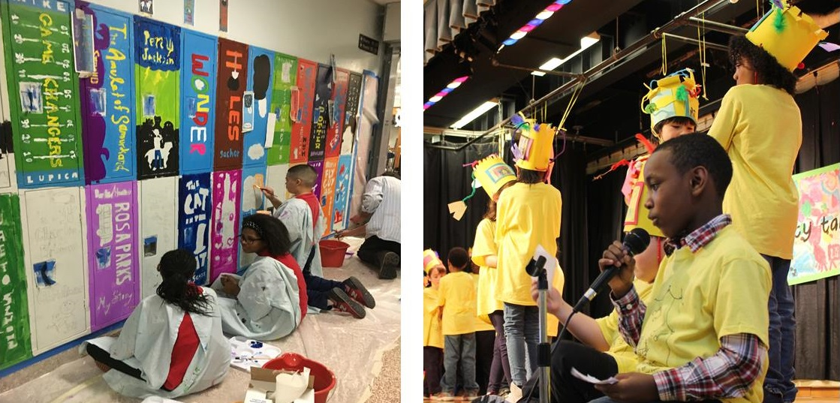

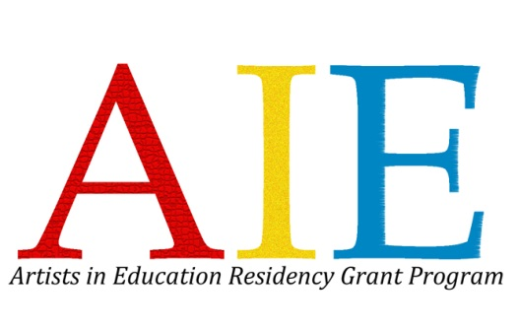

NEW JERSEY STATE COUNCIL ON THE ARTS
in partnership with
Young Audiences New Jersey & Eastern Pennsylvania

ARTISTS IN EDUCATION

RESIDENCY GRANT PROGRAM

Application for Schools & School Districts to be used with published Guidelines

Application Deadline: Friday, February 3, 2017

www.njaie.org

- 20+ Day Custom School Artist Residencies
- Grants for programming worth up to $10,000
- Open to all New Jersey Public, Private, Charter, and Parochial Schools serving grades Pre-K through 12

AIE Grant Program 2017–2018

For residencies to take place September 2017 – June 2018
GRANT APPLICATION ASSISTANCE
There are four helpful ways to get support for your application.

In-Person Workshops: All applicants, particularly those new to the Artists in Education Residency Grant Program, are encouraged to attend an AIE Residency Grant Workshop, which includes an introduction and overview of the AIE Program, activities designed to help schools plan for and prepare an application, and a question-and-answer period. Each workshop is led by AIE staff, a school teacher and/or administrator with residency experience, and AIE teaching artists.
Attendees receive documentation of professional development hours as recommended by the New Jersey Department of Education.
Wednesday, November 30, 2016, 10:00 am to 12:00 noon
Young Audiences New Jersey & Eastern Pennsylvania
200 Forrestal Ave. (First Floor)
Princeton, NJ 08540
Directions: http://yanjep.org/contact-us/

Thursday, December 8, 2016, 10:00am to 12:00 noon
Appel Farm Arts & Music Center
457 Shirley Rd. (Dining Hall)
Elmer, NJ 08318
Directions: http://www.appelfarm.org/plan-your-visit/directions.
This workshop is offered in partnership with Appel Farm Arts and Music Center.

Wednesday, January 11, 2017, 10:00am to 12:00 noon
Morris Arts / The Geraldine R. Dodge Foundation
14 Maple Ave.
Morristown, New Jersey 07960
Directions http://www.morrisarts.org/about/contact-us/
This workshop is will be held in the Dodge Foundation training room and is offered in partnership with Morris Arts.

To register for Technical Assistance Workshops, please visit the AIE website at www.njaie.org.
Call or email us: We are happy to speak to you by phone or email to provide guidance on the application process. Please contact Michelle Baxter-Schaffer, Artists in Education Administrator at 609-984-7025 or by email to michelle.baxter-schaffer(at)sos.nj.gov. If you already have a relationship with Young Audiences of New Jersey & Eastern Pennsylvania, or our regional partner agencies Appel Farm Arts & Music Center and Morris Arts, feel free to contact arts education staff at the agency of your choice to inquire about the AIE program.
AIE Teaching Artists: Schools already working with an AIE Teaching Artist can include them on their Steering Committee. The Steering Committee works together to draft the AIE application, including the teaching artist’s input on the art form as well as the supply and equipment needs. Schools that do not have a pre-existing relationship with an AIE Teaching Artist will have the opportunity to interview several AIE Teaching Artists and select their teaching artist after their AIE Grant application is approved.
1
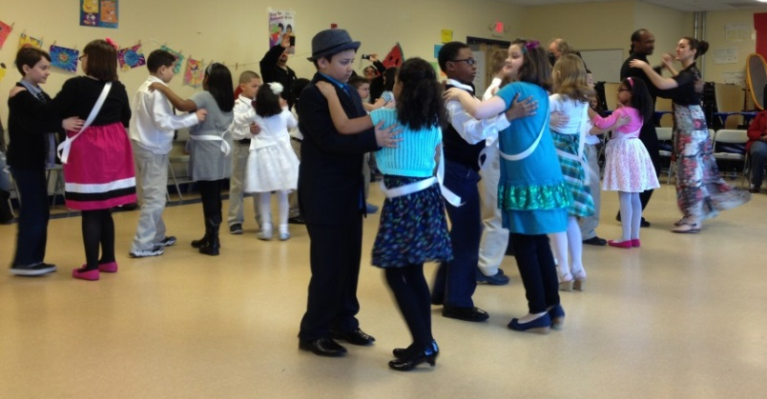
AIE guidelines and application can be viewed and downloaded online at www.njaie.org or www.artscouncil.nj.gov and in a LARGE PRINT version as well. Contact us if you are in need of special accommodation in filing this AIE grant application at (609) 984-7025.

THE ARTISTS IN EDUCATION PROGRAM

Guidelines and Application Instructions

Table of Contents
Technical Assistance Information | 1
About AIE | 3
AIE Program Goals, Objectives & Standards | 3
The Impact of AIE Residencies | 4
Residency Grant Introduction | 5
Components of AIE Residencies | 5-6
Evaluation Criteria | 8
Grant Application Sample Timeline | 9
Frequently Asked Questions | 10-11

Application Forms
Applicant Information Forms | A1-A2
Certification | A2
Grant Narrative | A3-A5
Residency Grant Budget | A6
Budget Narrative | A6
Checklist | A8
Glossary of Key Terms | A9-A10

For more than 40 years, the New Jersey State Council on the Arts (NJSCA) has recognized the value of partnerships. The foundation of the AIE Program is the partnership between professional artists and educators in order to bring students quality, long-term arts education.

Cover images: Students in Haledon School’s graphic arts residency with Teaching Artist Kevin Pyle; and students in Marshall Elementary School’s interdisciplinary residency with Teaching Artist Pat Flynn.
Above: Students in Vineland Public Charter School’s Latin and Ballroom Dance residency with Teaching Artist Mark “Flaco” Best.
2

ABOUT THE ARTISTS IN EDUCATION RESIDENCY GRANT PROGRAM (AIE)
Now in its 45th year, the Artists in Education (AIE) Program, a partnership of New Jersey’s professional artists, educators, and leading arts education providers, serves as a national model for effective and successful arts residencies. Experience how an AIE residency can help your school and district fulfill its goals and objectives for student performance, professional development, and community-building in and through the arts. An invaluable arts experience that can help prepare your students for the competitive world of the 21st century is within reach.
The Mission
The mission of the Artists in Education Program is to make the arts a basic part of a sound, quality education for all students Pre-K through 12, and to provide quality professional development for teachers through long-term residencies with professional teaching artists.
AIE PROGRAM GOALS AND OBJECTIVES
Goals:
- To make the arts a basic part of a sound, quality education for all students Pre-K through 12
- To assist educators in the development and implementation of innovative arts curriculum.
- To help schools fulfill their own goals and objectives for curriculum, professional development, and community connections in and through the arts.
- To aid in the implementation of the Core Curriculum Content Standards in the Visual, Performing, and Language Arts Literacy.

Objectives:
- To place the creative process of making art at the center of the residency.
- To focus on engaging students and teachers in the creative process.
- To provide professional development for teachers that can be applied to the NJ Department of Education’s requirements for continuing education.
- To develop new skills and knowledge that complements and expands current practice.

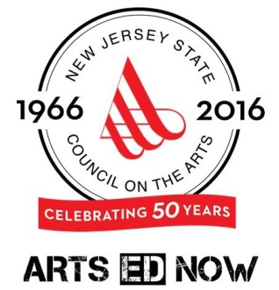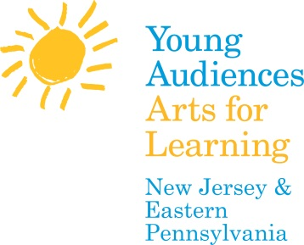

The Artists in Education (AIE) Program is a cosponsored project of Young Audiences New Jersey & Eastern Pennsylvania and the New Jersey State Council on the Arts, a Partner Agency of the National Endowment for the Arts. The program is carried out in partnership with Appel Farm Arts & Music Center and Morris Arts.

3

Impact
Here’s what schools have to say about the powerful impact AIE residencies have had on students, teachers and school culture:

Increased student self-confidence
“When we reflect on the impact of this AIE residency, we think specifically of certain students who may not have the opportunity to excel in academics. We saw these students come alive in their performances and then carry that high energy into their classwork.”
Mark Quiles, Principal at Seth Boyden Demonstration School in Maplewood
Students stretch, explore, and persevere
“Students learned the discipline of persistence when working on a project, and the importance of personal passion when creating. The presence of professional guest artists through the AIE grants have been invaluable to our educational mission. . .”
Scott Shaw, Supervisor for the Academy for Visual & Performing Arts, Morris County School of Technology in Denville
High-level critical and creative thinking
“Students developed the tools of thinking itself—careful observation of the world, mental representation of what is observed or imagined…. We use these same thinking tools in science, philosophy, math, and history. The advantage of the arts is that they link cognitive growth to social and emotional development. Students care more deeply about what they study.”
Alma Morel, Vice Principal, Thomas Jefferson Middle School in Teaneck
For students and teachers alike
“Our AIE grants play an integral part in developing an environment for professional learning communities (PLC), a state mandate beginning in middle school and continuing through high school (NJAC 6A:8). Schools can use AIE residencies to fulfill their obligation to meet this standard.”

Janice Marsili, Visual Arts teacher, David Brearley Middle/High School, Kenilworth
Increase in positive behavioral and social skills  “The students learned to work together for a common goal. They were able to see the importance of working through the steps to have a final product. Students had an increase in positive behavioral and social skills.”  Janene Askins, Vice Principal, Atlantic County Special Services School District | 4

RESIDENCY GRANTS: AN INTRODUCTION
THE AIE RESIDENCY GRANT
ELIGIBILITY: All New Jersey public, charter, private, and parochial schools serving grades Pre-K through 12 are eligible to apply.
INTRODUCTION
The AIE Program places highly qualified professional artists in classrooms throughout the state, presenting students and teachers with the opportunity to engage in and learn about the creative process.
Through the AIE Program, schools design residencies based on their own goals and objectives for curriculum, professional development, and community connections. Residencies focus on direct learning about the arts and the process of creating including the skills, techniques, and concepts of the art form. An artist in residence can also help classroom teachers with new approaches to traditional subjects through the arts.
Residencies are offered in a wide variety of disciplines and are a minimum of 20 nonconsecutive days. The focus of the residency may be class work with students and/or professional development for school staff.

AIE TEACHING ARTISTS
AIE teaching artists are professional teaching artists who are currently on the roster at AIE’s three partner agencies: Young Audiences New Jersey & Eastern Pennsylvania; Morris Arts; and Appel Farm Arts & Music Center. These artists have been chosen for both the quality of their artwork and their ability to create lively, substantial, and sequential arts programs in an educational setting. Through mentorships and professional development, they learn how to work collaboratively with teachers and administrators and bring the best possible programming to schools. Schools that are not already working with an AIE Teaching Artist will interview and select the artist to conduct the residency after grant awards are made.
Teaching Artists are required to complete a fingerprint-based background check prior to their work in AIE-funded school residency programs.

5
COMPONENTS OF AN AIE RESIDENCY
A glossary appears at the end of this packet with detailed definitions of terms used here. To ensure a successful residency and help schools attain their goals, schools are asked to:
- Form a Steering Committee to establish goals for the residency and provide support, assistance, and resources for the artist. Appoint an Administrative Coordinator, On-Site Coordinator, and a Teacher Liaison (if applicable) to lead the project. Steering Committee members, classroom teachers, the AIE Teaching Artist, and the AIE Partner work together to plan and implement the residency.
- Attend a Pre-planning Meeting to meet with your AIE Partner and identify artists to interview for your residency
- Hold a Planning Meeting to develop the residency plan and schedule. The Steering Committee, Teaching Artist, and your AIE Partner should all plan to attend.
- Host a twenty (20+) day residency during the school year, including: 16 workshop days, a planning day, a culminating event, and one post-culminating event reflection day. Each workshop day consists of approximately four consecutive 45-minute class periods plus teaching artists’ prep time.
- Work with your AIE Partner and the Teaching Artist to develop and implement a Professional Development Plan for the cooperating teachers.
- Arrange at least one Field Trip and/or schedule a Visiting Artist/Company to enhance the residency.
- Host a Culminating Event at the end of the residency that celebrates the students’ creative efforts and brings their work to a wider audience
- Gather participating students and teachers for a post-residency Reflection Day where they can meet one last time with the Teaching Artist and AIE Partner
- Commit to share your experiences and project with other schools at the End of Year Meeting, held annually in May, and at a meeting of your school board.

6
THE AIE RESIDENCY GRANT PROGRAM IN DETAIL
The AIE Residency Grant Program provides:
- Funds for a highly-qualified, AIE-approved teaching artist to work with students and teachers for 20 days or more during the school day
- An on-site evaluation of the residency
- Mentorship, training, and technical assistance for AIE Schools and Teaching Artists
- An AIE Partner to help coordinate and facilitate the residency
The School should be prepared to provide:
  - A school financial match of at least $2,000 – This “match” should come from the school’s existing budget and/or in-kind donations. Refer to the budget page for more information.
- Substitute teachers as required
- Supplies, materials, and equipment needed for the residency project
- Costs associated with a field trip or a visiting artist/assembly program
  - Necessary workspace, appropriate facilities, and maintain a productive working environment and collaboration with the Teaching Artist
  - A teacher in the classroom to work with the AIE Teaching Artist at all times.
  - Publicity to the local press regarding the artist and the AIE residency and introduce the AIE Teaching Artist and the project to the school and community
  - Documentation, evaluation, and publicity for the project, to help advocate support for arts education in your district

WHAT DOES A RESIDENCY YEAR LOOK LIKE AFTER RECEIVING A GRANT?
Sample timeline for AIE residencies (Please note: timing will vary depending upon the start date of the residency.)
Spring 2017
  - February 3, 2017: Grant Application deadline
  - May 2017: Grantees notified of awards, pending funding approval
  - July 2017: final funding approval announced
Summer 2017
  - Pre-planning meeting takes place with AIE staff
  - AIE Grant Agreements are reviewed
  - Artist interview dates are identified
Fall 2017
  - Artist interviews continue and selection finalized
  - Planning meeting takes place with Steering Committee, Teaching Artist, and AIE Partner
  - School returns signed AIE Grant Agreement before residency begins
  - Professional Development Plan is drafted and implemented
  - Residency begins
7
Winter 2017/2018
  - Residency continues
  - Visiting artist(s) comes to school and/or field trip takes place
  - Interim progress reports are completed by the teaching artist and the school team
  - Prepare and submit application for 2017-18 residency (if applicable)
Winter/Spring 2018
  - On-going publicity for the program, presentation to the School Board
  - Culminating/Community Event
  - Post-culminating event reflection day
  - End-of-Year Meeting held for all Artists in Education Residency Grant recipients (May)
  - Final Documentation and Evaluation submitted within 30 days of the conclusion of the residency, but no later than June 30, 2017 (for residencies ending in May/June).

HOW ARE AIE GRANT APPLICATIONS EVALUATED?
AIE Grant Application Review Process
  - An independent review panel evaluates applications based on the criteria listed below. The review includes a scoring metric and written panel comments. The comments are written to be constructive and informative for a school applicant. The panel process takes place in March 2017.
  - Those schools who score in the top tier of the evaluation are then contacted for a brief follow up interview with AIE staff via conference call. Key members of the school Steering Committee should be available for this interview, which is an opportunity to clarify points that the review panel comments upon, and to ensure readiness. Interviews will take place in April 2017.
  - Final award determinations are made based on the panel score, interviews, available funding, and State Arts Council priorities.

Evaluation Criteria for all AIE Residency Grant Proposals:
  - Ability of the proposed residency to augment existing arts curricula
  - Ability of the school to accomplish the residency goals, including space, equipment, and support
  - Evidence of administrative and staff support and participation
  - The school’s understanding of and commitment to the needs of the artist
  - Applicant’s long-term commitment to sustaining the benefits of an AIE residency at its site
  - Adequacy of the matching fund requirements and appropriateness of the budget
Additional Criteria for Reapplying AIE School Grantees:
  - Ability of the proposed residency to effectively build upon past AIE residencies and expand upon and reflect the learning and experience
  - Evidence of a commitment to institutionalize the residency benefits through professional development in past and proposed projects
8
GRANT APPLICATION TIMELINE
Fall 2016
  - AIE guidelines and application available
  - Form Steering Committee
  - Appoint an On-site Coordinator, Administrative Coordinator, and Teacher Liaison (if applicable)
Winter 2016/2017
  - Review guidelines and application for AIE Residency Grant Program
  - Attend Technical Assistance Workshop; additional technical assistance is available via e-mail or phone
  - Write narrative; prepare budget and support materials
  - Submit proposal
Grant Deadline: Friday, February 3, 2017
A complete application packet includes: ONE electronic copy of the complete online application emailed to michelle.baxter-schaffer(at)sos.nj.gov and ONE typed hard copy (with original signatures in blue ink) and support materials. Only complete applications postmarked by this date will be forwarded to the panel for review.
April 2017
  - Schools that score in the upper tier of the panel review are contacted for an interview. Steering committee meets with interview team via conference call to respond to panel comments. Final award determinations are made based on panel score, interviews, available funding and State Arts Council priorities. Please note that an interview is not an indicator or guarantee of grant funding; more schools are asked to interview than available funding will support.
May 2017
  - Notification of grant award by email and mail at the end of May. Please note: all awards are pending the availability of state funds and are confirmed in July.

9
FREQUENTLY ASKED QUESTIONS

Q. What is the size of the Grant?
A. Grants are for programming worth up to $10,000.
Q. What are the financial responsibilities of the school/district?
A. The school/district must provide a financial match of at least one-third of the grant funds supplied for the Teaching Artist (Teaching Artist funds supported by the grant are worth $6,000, so 1/3 would be $2,000). Matching funds can be made in cash and/or planned expenditures that already exist in the school budget. Schools should anticipate their commitment of teacher and administrator time for meetings and planning, substitute teachers, equipment, supplies, materials, and other expenses needed for the AIE Residency project will constitute their school financial match. Schools may also choose to include cash expenditures such as additional residency days, visiting artists, field trips, etc. in their financial match figure. Sources of the match funds can include the existing school budget, PTA fundraising, a local bank, etc. Funding sources listed on the grant application should be secured in advance.
Q. How are the grant funds managed?
A. Funds for artist fees are paid directly by Young Audiences New Jersey & Eastern Pennsylvania to the teaching artist. The school is responsible to manage and track their own spending for equipment, supplies, teacher and administrator time, etc.
Q. Who should write the grant application?
A. The grant application should be developed and written by the Steering Committee, which is composed of teachers, administrators, parents, and members of the community. The committee establishes goals based on the school’s needs, chooses an artistic discipline for study and experiential exploration, writes and submits the grant application, and then implements the residency.

Q. What types of disciplines are available?
10
A. Residencies are available in the following disciplines: Dance, Music, Theatre, Opera/Music Theatre, Visual Arts, Design Arts, Crafts, Photography, Media Art, Creative Writing*, Interdisciplinary** and Folk Arts.** Additional information can be found at http://www.njaie.org/residencies/featured. Schools already working with an AIE Teaching Artist may choose to continue to work with that artist, including them on the Steering Committee as the grant application is prepared. Otherwise, the school Steering Committee will interview and select the Teaching Artist to conduct the residency after the grant awards are made. The AIE Partner will help the Steering Committee identify potential Teaching Artists for an interview process.
*Although Creative Writing is one of the many disciplines supported, only proposals to sponsor long-term writing residencies are covered by this program. Short-term writing residencies (5 days) are coordinated through the New Jersey Writers Project, and administered by Writers Theatre of New Jersey. For information, contact 973-514-1787 x21.
**Schools interested in Interdisciplinary or Folk Arts residencies must first consult with AIE staff at 609-984-7025.

Q. How many students can be served in a residency?
A. Characteristically, a core group consists of students who meet with the AIE Teaching Artist every workshop day, with a residency day serving three or four core groups, for a total of approximately 75-100 students. Schools seeking to increase the size of the core group (for instance, an entire grade level that is more than four classes) should factor in increased Teaching Artist hours or days into their budget. Please contact AIE for assistance. Additional students can be served as a participating group - they may meet with the AIE Teaching Artist on occasion, attend visiting artist’s events and assemblies, and participate in field trips or culminating and other events related to the residency.

Q. What is the application deadline?
A. The AIE School Grant Application postmark deadline is Friday, February 3, 2017. An electronic version of the application must also be emailed by this date. Schools ranked highest by the application review panel will be contacted to schedule an interview to take place in April.

Q. When do I find out if my school received a grant?
A. Notification will be emailed and mailed in late-May to the designated school contact. Grant awards are made pending the availability of state funds and are confirmed in July.
11
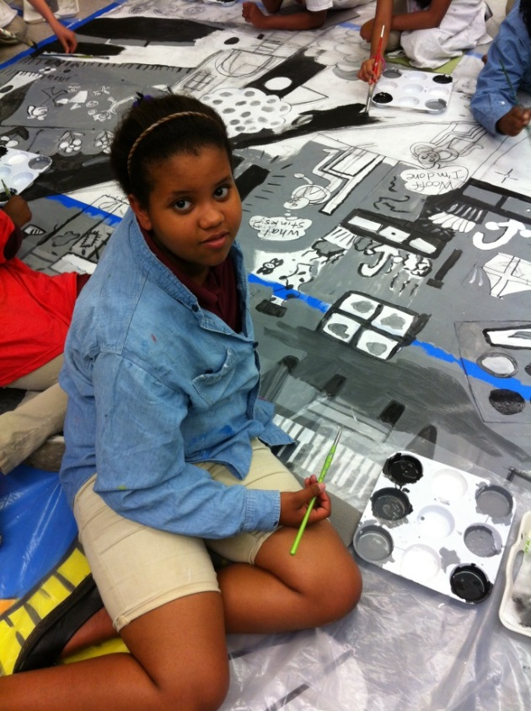

A student from Sussex Ave. School in the Newark Public School District works on the mural designed by the students with Teaching Artist Kit Sailer.

Please note: Dates and other information is subject to change. Please check the website (www.njaie.org) for changes prior to submitting your application.

End of 2017-2018 AIE Guidelines - Application Follows
End
This application is available online at www.njaie.org and www.artscouncil.nj.gov.

AIE GRANT APPLICATION INSTRUCTIONS

Please review the grant application guidelines carefully before getting started.

Special Instructions for Reapplying Schools:
Please confer with your AIE Partner when developing a new application. You should also request an AIE Partner Letter of Consideration, as well as one from your most recent AIE Teaching Artist, to include in your application packet. If you plan to work with the same AIE Teaching Artist for the proposed residency, please include them in the planning and application process.
Handwritten, incomplete, or faxed applications will not be accepted.

A checklist to confirm that your application satisfies the submission requirements can be found on the application (page A8).

If you need any help with the application, or if you have questions, please contact AIE staff at
(609) 984-7025.

A complete application packet includes:

- One digitally-submitted copy, assembled as one complete .doc or .pdf document titled as follows: yourschoolnameAIE-FY18.(doc/jpg/pdf) emailed to michelle.baxter-schaffer(at)sos.nj.gov. Please have the subject line read: Your School Name – AIE Application

- One (1) original copy with support materials - with original signatures in blue ink;

Emailed and Postmarked by Friday, February 3, 2017

Via US Mail:
Michelle Baxter-Schaffer, Artists in Education Program
c/o The New Jersey State Council on the Arts
PO Box 306
Trenton, NJ 08625

Via Ground Shipping (UPS, FedEx, etc.):
Michelle Baxter-Schaffer, Artists in Education Program
c/o The New Jersey State Council on the Arts
225 West State Street, 4th Floor
Trenton, NJ 08608

Extension requests must be received via email to michelle.baxter-schaffer(at)sos.nj.gov no later than January 20, 2017. Only one extension request will be permitted per school. Please note: a request does not guarantee an extension will be permitted.

Applicants are advised to mail applications early.

Please retain a copy of your application and the guidelines for future reference.

AIE Residency Grant Application
The Artists in Education Program is a cosponsored project of Young Audiences New Jersey & Eastern Pennsylvania and the New Jersey State Council on the Arts/Department of State, a Partner Agency of the National Endowment for the Arts. The program is carried out in partnership with Appel Farm Arts & Music Center and Morris Arts.

PLEASE READ THE AIE PROGRAM GUIDELINES BEFORE COMPLETING THESE FORMS.

Residencies must be a minimum of 20 days and be part of the regular school day. A residency day is considered to serve approximately four consecutive 45-minute class periods. The core group of students should meet with the Teaching Artist during every workshop day. Proposals for less than the minimum residency length will not be considered.

First-Time and Reapplying Applicants: You must submit at least 2 letters of support with this application. One must come from your school principal.
First-Time Applicants: If you have a pre-existing relationship with an AIE Teaching Artist that you intend to work with in your AIE-funded residency, please be sure to include the artist on your Steering Committee. If you have not been working with an AIE-approved artist, you and your AIE Partner will select an AIE artist through interviews after receiving notice of a grant award.

Previous AIE Grantee Applicants: If you are continuing to work with an AIE-approved artist from a prior AIE residency, please be sure to include the artist on your steering committee. Previous and current AIE Grantees must include Letters of Consideration from their AIE Partner, as well as from the AIE Artist with whom they worked most recently. Include, too, documentation of past residencies (e.g. newspaper articles, press releases, blogs, student work, photographs, etc). Send no more than 5 pages of supporting materials with your application.

APPLICANT INFORMATION
Has your school previously received AIE grants? Yes No
If yes, list year(s) grants awarded:
Proposed participating target grade(s):
Proposed total number of students participating in residency project activities (participating group):
Proposed total number of students who will meet with the teaching artist every residency day (core group):
Proposed total number of adults (teachers, parents, etc.) impacted by the project activities:
Please provide a 50 word summary of your grant proposal, including the art form, students and grade levels to be served, and primary residency goals:

Name of School |  |  | Superintendent/CEO |  |  | Federal ID Number

School District

School Street Address

City

NJ | Zip | County
A1

Certification: By signing below, I certify that I have read and support the residency proposal.
Principal’s Name |  | Principal’s Telephone |  | E-Mail (provide one address only)
Authorizing Official’s Signature (Blue ink, please) |  |  |  |  | Date (mm/dd/yyyy)

Legislative District: State Federal
(This information is available at http://www.njleg.state.nj.us/members/legsearch.asp and http://www.house.gov/representatives/find/.)
APPLICANT STATUS  Which category best describes your organization’s  legal status? Please place an X next to appropriate selection. |  | APPLICANT INSTITUTION  Which category best describes your organization?  Please place an X next to appropriate selection.
__ Nonprofit Organization  __ State Government  __ Regional Government | __ County Government  __ Municipal Government  __ None of the Above | __ School District  __ Elementary School  __ Middle School | __ Secondary School  __ Vocational/Technical School  __ School/Other: _________________

DISCIPLINE: Choose the ONE discipline which best describes the desired residency or project, and place an X next to the category for which you are applying. Additional information on categories can be found at http://www.njaie.org/residencies/featured.

Performing Arts  ___ Dance  ___ Music  ___ Opera/Music Theatre  ___ Theatre | Visual Arts  ___ Visual Arts  ___ Design Arts  ___ Crafts  ___ Photography  ___ Media Art | Other  ___ Creative Writing  ___ Interdisciplinary*  Pertaining to art forms/art works that integrate more than one arts discipline to form a single work (e.g., collaboration between/ among the performing and/or visual arts) as well as performance art.  ___ Folk Arts*  *Schools interested in applying for these residencies must first consult with AIE staff at 609-984-7025.

Steering Committee/ Residency Support Structure: Refer to Glossary (p. A9-A10) for definitions.
Please provide the name, phone number, and email address of the contact person for questions regarding this grant proposal. Name: Phone number: Email address:

List the members of the Steering Committee:
On-site Coordinator: Title/Position: Email address:
Administrative Coordinator: Title/Position: Email address:
Teacher Liaison (if applicable): Title/Position: Email address:
Teaching Staff (Please include grade level and subject area or current title, specifying those who will have a direct role in the residency):
Community Members (Please include affiliations: i.e. parent, business person, Teaching Artist, etc.):
A2
How did you hear about the AIE Grant?
An AIE School From my Administrator AIE Staff Technical Assistance Workshop
Direct Mail Email aTi Teaching Artist Other (please specify)

Pre-planning Meeting: Refer to the guidelines (page 6) for more details
Please sign below to signify that your school agrees that both your On-Site Coordinator and Administrative Coordinator will participate in a pre-planning meeting with the AIE staff.

Signed: ______________________________________________________________________________

Residency Grant Narrative

INSTRUCTIONS FOR FILLING OUT FIELDS BELOW: Fields are set with word limits and will end when the limit is reached. As you type, the field will expand to accommodate your entry and push subsequent content down. This will automatically increase the amount of document pages that you will submit and document length will vary for each user.
1. Please describe the proposed residency and how it will augment the existing arts curricula at your schools’ site. Why was this art form selected? (750 word limit)

2. Please describe what students will learn from this residency. List no more than 5 student outcomes you anticipate from this residency. Please be succinct and realistic in your anticipated outcomes.
- Students will

- Students will
- Students will
- Students will
- Students will

3. Please describe what teachers will learn from this residency. List 3-5 teacher outcomes you anticipate from this residency. Please be succinct and realistic in your anticipated outcomes.
- Teachers will
- Teachers will
- Teachers will
- Teachers will
- Teachers will

4. Describe the artistic processes that students and teachers will engage in to meet the outcomes stated in questions 2 and 3. (500 word limit)

5.Number of Core groups: Number of students in each Core group:
(Please refer to Core Group definition in glossary)
Briefly describe the criteria for selecting the core and participating groups. (500 word limit).

A3
6. How do you plan to document and evaluate the outcomes of the student and teacher goals described in questions 2 and 3? (500 word limit)

7. Does your school/district have an improvement plan or set of adopted goals that includes the arts? If yes, please describe:

8. Please provide the following demographic information:
 | # Courses | # Full-Time Staff | # Part-Time Staff | Comments
Creative Writing:
Dance:
Media Arts:
Music:
Theatre:
Visual Arts:
Other:

Site and Community
9. Briefly describe your school and community including geographic and socio-economic characteristics.

10. Please describe any existing or planned partnerships with community or cultural organizations.

Support/Scheduling
11. Please describe how you anticipate scheduling student workshops (with focus on aligning scheduling for the core student groups). Be sure to provide the projected number of times per week, length of sessions, and the general time of year for the proposed residency. (See Residency Components and Sample Timeline on pages 5-9 of Guidelines. Please remember that 4 of the 20 residency days include the planning meeting, professional development day, culminating event, and reflection day.)

12. Please describe how you anticipate scheduling planning meetings with your Steering Committee, AIE Teaching Artist, and AIE Partner.

Support/Facility
13. Please describe the artist’s work space in your school, with particular consideration for the specific needs of the artistic disciplines involved. Describe the facilities/equipment available for the artist’s use. (300 word limit)
A4
(Reapplying Grant Recipients Only)
14. Briefly summarize what took place in past AIE residencies. Describe how the proposed residency relates to the experiences and learning of those residencies. Please elaborate on any proposed changes in focus or artistic disciplines. Will the same or different artists be involved? Reminder: Please provide no more than 5 pages of documentation from past residencies. (500 word limit)

15. Describe how previous and proposed residencies and professional development activities will help to create sustainability for the arts in your school. (500 word limit)

Reminder: Current and previous AIE Grantees reapplying for funding should include Letters of Consideration from their AIE Partner as well as from the most recent AIE Artist with whom they worked.
A5
A5
Proposed AIE Residency Grant Budget

School Match Item  The list below contains a variety of items schools have paid for to support their AIE residency. Please decide which items your school will need in order to meet the requirements of your proposed residency. | Amount  The total amount matched by the school should be at least $2,000, which is 1/3 the amount AIE pays for the Teaching Artist fees for a 20 day residency. | Income Source  Please list how the school will secure the funds needed (i.e.: fundraising, existing budget, in-kind donation, etc.) In-kind donations should not comprise the bulk of your match.
Teacher Release Time | $
Substitute Teacher Fees | $
Materials / Supplies | $
Equipment | $
Field trip | $
Visiting Artist(s) / Assembly Program | $
Artist Tools Rental Fee | $
Extra Residency Days (Teaching Artist Fee of $300 x ____ days) | $
Administrative Costs | $
Documentation / Evaluation / Publicity | $
Other: | $
Other: | $
Other: | $
Total | $
For budget-related questions, consult the definitions at the end of this section,
or call AIE at 609-984-7025.
BUDGET NARRATIVE
Please provide a brief explanation of your school’s match, and how you arrived at the items you listed as necessary to support your residency.

Definitions of Budget Items:
Teacher Release Time / Substitute Fees: Costs as needed for time outside of class time spent by teachers for the residency project: planning, attending workshops, field trips, completing documentation/evaluation, etc. (Calculated by $Hourly rate X # Hours = $Total Release Time/ Substitute Fees). In most instances, this amount is a significant portion of the school’s financial match amount.
Materials / Supplies: Non-permanent items, including paper, paint, etc. to be used in the residency. When drafting the budget, please make sure the supply allocation supports the proposed residency.
Equipment: Permanent items, such as a printing press, camera, video recorder, etc. that are purchased by the school specifically for the residency.
Field Trips: Costs for bus transportation, admission fees, etc.
Visiting Artist(s) / Assembly: Individual visiting artists should receive the same $300 per day as residency artists. Performing groups/company fees may vary (for assembly programs).
Artist Tools Rental Fee: Some residencies may require special tools that the school does not necessarily need/want to purchase for a one-time residency. The school may negotiate a rental fee with the Teaching Artist, if the Teaching Artist owns the tools necessary for the residency (i.e.: power tools).
A6
Teaching Artist Fee: The required AIE Teaching Artist fee is $300 per teaching day, which should include about 4 consecutive class periods per day. The minimum number of residency days is 20 per year ($300 x 20 days = $6,000 minimum for AIE Teaching Artist fees per year). The AIE Partner manages these funds directly from the AIE Grant. The 20 days covered by the AIE grant include the planning meeting, professional development, residency days, and culminating event (and reflection day, if applicable).
Administrative Cost: Estimated costs for time dedicated to the residency by administrative staff such as principals or supervisors. (Calculated by $Hourly rate X # Hours = $Total Administrative cost)
Documentation / Evaluation / Publicity: Costs of video duplication, printing, postage, etc.
Other: Expenses associated with the residency, which do not fit into other categories.
In-Kind Sources: List the individuals, businesses organizations, etc. and the estimated value of the goods and services that will be donated for residency use. (An example of donated services: A parent who is a carpenter donates time with construction. An example of donated goods: A local art supply store contributes paint.)

A7
A8
FINAL CHECKLIST
Please use this checklist to indicate the items submitted and ensure that
your application packet includes all the required materials.
Only complete applications will be considered.
School or School District Name:
APPLICATION CHECKLIST
Completed application form, including:
Applicant Information | 1 Original  1 Email
Certification (Email copy can be without signatures) | 1 Original  1 Email
Residency Grant Narrative | 1 Original  1 Email
Budget | 1 Original  1 Email
Required Documents – to be mailed with signed original
Two (2) Letters of Support  (One from the school principal) | 1 Original
Documentation from Past Residencies  (Reapplying schools ONLY) | 1 Original
Letter of Consideration from AIE Partner  (Reapplying schools ONLY) | 1 Original
Letter of Consideration from Most Recent AIE Artist  (Reapplying schools ONLY) | 1 Original

Thank you for your application.
Please keep an additional copy for your records.
Awards will be announced in late May 2017.
GLOSSARY OF KEY TERMS & AIE Residency COMPONENTS
School Team:

ADMINISTRATIVE COORDINATOR (AC)
A district-level person; the principal, vice principal, or other administrator of the site (depending upon the administrative structure in place). The AC has the necessary authority and responsibility for scheduling and making all other arrangements necessary for the smooth operation of the AIE Program.

AIE PARTNER
Schools that receive an AIE grant work with one of the AIE Staff who will help facilitate the residency and provide technical assistance, support, and guidance throughout the residency.

AIE Teaching ARTIST
An AIE Teaching Artist is a professional artist who has been approved to work in the AIE Program. AIE Teaching Artists are interviewed and selected by the school Steering Committee, with the assistance of their AIE Partner, and lead the residency for a minimum of 20 days. The artist helps plan all the residency components and works with the Steering Committee to plan a field trip or invite a Visiting Artist.

CORE GROUP
The students who will work with the AIE Teaching Artist each workshop day throughout the project. Characteristically, a core group consists of a class of 25-30 students, with a residency day serving up to three core groups, for a total of approximately 75-100 students. Schools seeking to increase the size of the core group (for instance, an entire grade level) should factor in increased Teaching Artist days into their budget. Please contact AIE for assistance.

ON-SITE COORDINATOR (OSC)
The AIE Teaching Artist’s liaison to the site, students, and community. The OSC is generally a teacher, department head, or vice principal. He or she works cooperatively with the artist, and continues to stimulate and expand art activities at the site after completion of the residency. NOTE: If the OSC is not a teacher, then a Teacher Liaison should also be identified.

PARTICIPATING STUDENTS
Students who work with the AIE Teaching Artist on a less regular basis than the Core Group(s). For example, these students might rotate through a designated period during the AIE Teaching Artist’s day or attend related activities such as an assembly or a field trip.

STEERING COMMITTEE
Composed of members of the faculty and administration, parents, and members of the community. It establishes goals, writes and submits the grant application, and then implements the residency. The AIE Teaching Artist and the AIE Partner become part of the committee at the start of the residency.

TEACHER LIAISON (TL)
Represents teachers on the Steering Committee when the OSC is not from the site teaching staff. The TL ensures that the teaching staff from the sponsor site has direct input and involvement in the residency project from inception through completion.

VISITING ARTIST
Guest artist(s) invited by the AIE Teaching Artist to present a workshop or demonstration that expands the focus of the residency. The Visiting Artist is present with the AIE Teaching Artist to help make connections to the residency discipline.

A9
Residency Components:

CULMINATING EVENT OR ACTIVITY
An event for the community (such as a dance/music/theatre performance and/or exhibition of student art) that celebrates students’ creative efforts during the residency, brings their work to a wider audience, and affirms the importance of the arts in learning.

Documentation & EVALUATION
An Interim Report is due to the AIE Administrator (via email) around the time 1/3 of the residency is completed. A Final Report (which documents and evaluates the project) is due to the AIE Administrator no later than 30 days after completion of the residency (no later than June 30, 2017 for residencies ending in May/June). Documentation and evaluation should be on-going and submitted electronically throughout the residency, using the format provided by AIE Staff at the start of the residency. This will include documentation & samples of work produced, photographs, narrative responses, evaluation responses from students, teachers, administrators, community members, and the AIE Teaching Artist, as well as a budget component, demographic information, and publicity samples.

PLANNING MEETING
Once the Teaching Artist has been identified, the Steering Committee, Teaching Artist, and AIE Partner will meet before the residency to review the grant agreement, residency schedule, supplies and equipment needed, budget, student and teacher goals, etc. This meeting is typically held in late summer or during the fall.

PRE-PLANNING MEETING
Once the grants have been awarded, the On-site Coordinator and Administrative Coordinator will meet with their AIE Partner to discuss the residency, make any necessary updates, and identify Teaching Artists to interview for the residency.

PROFESSIONAL DEVELOPMENT PLAN
A plan developed and implemented during the residency in cooperation with the AIE Teaching Artist to help teachers and staff fulfill their Professional Development goals for the AIE Residency. The professional development activities might take the form of a workshop, a series of hands-on individual lessons in specific art-making techniques, co-teaching a designated lesson, or other professional development/adult education models. PD should be planned in advance, documented, and evaluated.

PUBLICITY
Schools are responsible for publicizing the residency to the community through print and electronic media. The AIE Grant Agreement provides the appropriate language to use in press releases when defining the program and its managing entities.

REFLECTION DAY
The school must use one of its 20 residency days to hold a post-culminating event reflection day. This day offers students and teachers the opportunity to meet one last time with the Teaching Artist and AIE Partner to reflect on the project and discuss how the residency may impact the school moving forward. This day is an ideal opportunity to capture important feedback for the Steering Committee, AIE team, and the required Final Report.

RESIDENCY DAY
Based on four 45-minute consecutive class periods with additional time for class preparation as needed. The residency day must be during school hours. After-school hours are not covered by AIE funding.

#End of 2017-2018 AIE Residency Grant Application#
A10

