$5,000* Arts Education Grants
for New Jersey and Eastern Pennsylvania Schools
Application Deadline: Friday, October 5, 2018 at 3pm

Young Audiences New Jersey & Eastern Pennsylvania (YA) is pleased to offer Arts Education Scholarships of up to $5,000 to fund assembly programming in schools in New Jersey and Eastern Pennsylvania.

The grants are designed to bring extraordinary and inspiring arts performances delivered by YA’s team of professional teaching artists. Each program is developed to maximize students’ experiences with quality arts programs, and to provide opportunities to understand the cultural importance of the arts and creativity.

Your school will work closely with a professional from Young Audiences’ staff to plan your school’s arts assembly programs based on your specific needs.
Questions about YA’s Arts Education Scholarships? Call Donna Reckelhoff at 866-500-9265.

*up to $5,000

What Your School Gets

Your school would receive Young Audiences assembly programs valued at up to $5,000 including guidance and support from Young Audiences staff to assess your school and student needs and develop a customized plan for YA’s arts programs. Based on your plan, YA will schedule professional artists to come to your school and provide appropriate assembly programs for the entire school population.
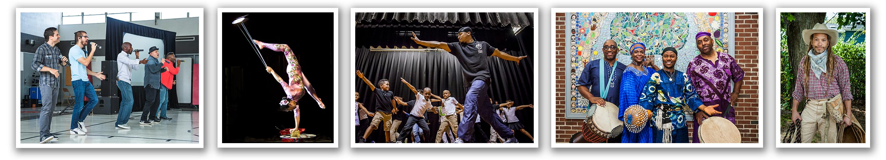
Visit www.yanjep.org for more information about YA’s assembly programs.

What Your School Gives

- With assistance from Young Audiences, your school will publicize the grant award and information about the programs to parents, your school board and the local press.
- Your school will assist YA in collecting documentation of your project with photos, videos and a final report. Other information, which may include teacher and student evaluations of their experiences, may also be requested by YA.
- Your assigned program coordinator and the school principal will meet with a YA representative to discuss your school’s current and ongoing programming needs.

Eligibility and Criteria
Eligible schools must be:
- a private, public or charter school.
- a preschool, elementary, middle or high school.
- located in New Jersey or Eastern Pennsylvania*.

Grants are awarded on a competitive basis and evaluated on:
- meeting the eligibility requirements as listed above,
- the school’s commitment to bringing quality arts programs to its students, teachers and community,
- demonstrated financial need including but not limited to: recent budget cuts, a history of insufficient school funding, a fiscal crisis within your district or school community, natural disasters, etc.,
- the ability to schedule programs within the 2018-2019 school year.
Additional Information
- The Program Coordinator listed on the application will receive an email confirmation within 48 hours to confirm receipt of your application. If you do not receive a confirmation within this time, please call or email YA.
- Winning applicants will be posted on Young Audiences’ website on or before October 19th.
- Planning with Young Audiences staff will occur in October-November.

*Eastern Pennsylvania is defined as: Bucks, Montgomery, Chester, Delaware, Philadelphia, Lehigh, and Berks
Counties.

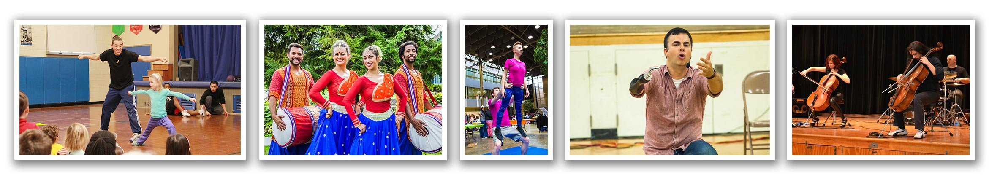
Application Deadline: Friday, October 5, 2018 at 3pm
YA Arts Education Scholarship Application, page 1
How to Apply:
- Complete the application by typing in the fields provided (or in a separate document).
- Print the application.
- Sign the application (Principal and Program Coordinator signatures are required).
- Scan to PDF and return it to Young Audiences via email to donnajr@yanjep.org
or fax to 609-243-8999. For more information call Donna Reckelhoff at 866-500-9265.

Name of School
Address
Phone
Number of Students
Grade Levels Served
Free/Reduced School Meal Rate

Required Signatures—please sign, scan and include in your application.
Principal Name
Principal Signature
Principal Email
Principal Phone
Program Coordinator Name
Program Coordinator Signature
Program Coordinator Title
Program Coordinator Email
Program Coordinator Phone

YA Arts Education Scholarship Application, page 2

Please answer the following questions adding no more than three pages (add separate pages as necessary):

- Why do you feel your school should be selected for this scholarship?

- Is there a special need or challenge faced by your school which arts performances can help meet?

- Describe your school’s economic situation that qualifies you for a scholarship.

- Which art form(s) are you most interested in bringing to your students?
Theatre/Drama/Storytelling Music Dance/Movement Literary Arts
- Are you currently receiving arts funding from any other grants or organizations?
If yes, please describe the projects you are doing.

- When would you anticipate programs happening? (Programs must occur during the 2018-2019 school year and conclude by June 2019.)

- If awarded the YA Scholarship, is your school able to provide any matching funding towards programming? (Matching funds are encouraged, but not required.)

- How did you hear about the YA Arts Education Scholarship?

Deadline: Friday, October 5, 2018 at 3pm

