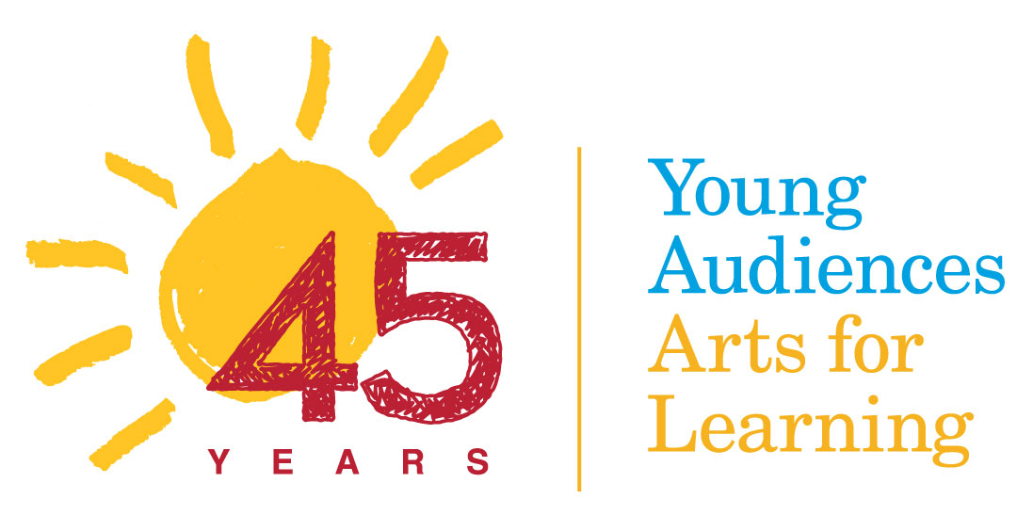

**FY17 BOARD SURVEY**

**COMMENTS/COMMITTEE**

As discussed at the September Board Meeting, each of the comments from our 2016/17 Board Survey has been assigned to the appropriate committee. The Committee on Trustees asks that you give the comments careful consideration, and respond appropriately, even there is a deliberate determination that no action be taken. Ann Betterton can share the author of the comments for follow-up, when needed.

**Arts Education**

# Q3 Identify those areas of potential Board focus that are most needed over the next 1-2 years to ensure the organization succeeds against its mission (check all that apply.)

*My priority area of focus (not included above) would be to continue to push the expansion of our programs both in terms of types of programs offered and number of children reached. Since I have joined the board, I have seen program sales decline every year. This would be accomplished through a combination of all of the priorities above as well as marketing efforts*

*A priority must be developing and reporting on indicators of impact. We can start small and expand the data and the statements we can make as we gain more experience.*

# Q10 The work of Young Audiences is guided by several core beliefs, one of these being that "All forms of diversity are valued, we strive to integrate diversity in all aspects of our work so that our organization serves and reflects the diversity of New Jersey and Eastern Pennsylvania."  How would you like to see this value expressed in our work?  How would you implement this core belief at the Board level?

*I believe that diversity is a priority, and I know that the higher socioeconomic audience*

*I do suggest we examine how diversity is represented and taught about in the art workshops/residencies/performances to ensure student participants understand the roots, traditions, and beliefs of diverse cultures, including their own, and not potentially learning misappropriation of art forms or cultural artifacts. Though I'm certain YA does not promote it, we may want to help the artists be aware of some common issues and missteps that occur in arts education around cultural diversity and teach them culturally responsive techniques of teaching rather than more traditional multicultural models*

*In our work, I would like to see us develop more programs targeted to helping children understand different cultures through explicit messages. Perhaps we are already doing this. At the board level, we need to work to increase diversity of all kinds, especially ethnic and geographical diversity. We must make certain that our board continues to be welcoming to all new board members. We are really good at this. It will help us retain trustees from different backgrounds and perspectives*

# Q11 Our committees are: Arts Education, Benefit/Dazzle, Finance, Audit, Committee on Trustees, Planning & Institutional Advancement, and Development. Our task forces are: Advocacy, Personnel and Sales & Marketing. Do we have the right committees/task forces? How can they be more effective?

The majority of Trustees feel that, at this point, we have the right committees. There were several comments related to committees vs. task forces - clarifying the differences between them and re-evaluating the classification of our groups, with an effort towards maximizing productivity and minimizing Trustee/staff time. There was also a suggestion that we add a committee on research and evaluation or a very strong charge about research and evaluation, perhaps as part of Arts Education. One Trustee felt we might want to add a taskforce for Diversity, Equity, and Inclusion to help guide our work.

**Comments for all committees to consider:**

# Q4 Good nonprofit boards have a number of enablers in place to allow them to work effectively and productively. Please rate our Board against these enablers.

*Governance work is excellent. Challenge continues to be achieving greater diversity on the board*.

# Q10 The work of Young Audiences is guided by several core beliefs, one of these being that "All forms of diversity are valued, we strive to integrate diversity in all aspects of our work so that our organization serves and reflects the diversity of New Jersey and Eastern Pennsylvania."  How would you like to see this value expressed in our work?  How would you implement this core belief at the Board level?

*I think we need a shared understanding of what diversity, inclusion and equity mean for YA and what we will do about it given our mission. This can't be a check the box exercise.*